# 

# 

# 

# On Career Success: Regulatory Focus and the Moderating Influence of Optimism and Stress

# 

Tan Kia Leng A0245117L

Department of Psychology, National University of Singapore

PL3231: Independent Research Project

Dr. Jia Lile

Mentor: Ong Hee Seng

17 November 2023

# Table of Contents

# 

# 

**Introduction 3**

**Methodology 4**

**Results and Discussion 5**

Simple Correlations 5

Moderation Effect of Optimism on Promotion Regulatory Focus on Career Success 6

Concurrent Correlations 6

Future Predictions 9

Moderation Effect of Stress on Prevention Regulatory Focus on Career Success 10

Concurrent Correlations 11

Future Predictions 13

**Conclusion 15**

**References 17**

**Appendix A: Regulatory Focus Strategies Scale 19**

**Appendix B: Successful Career Success Inventory Scale 20**

**Appendix C: Moderators 21**

**Appendix D: Plots for all analyses 22**

# 

# Introduction

Regulatory focus theory (Higgins, 1998) proposes that individuals have two distinct means of motivation when working towards their goals. Individuals adopting promotion-focused self-regulation work towards attaining positive outcomes while individuals adopting prevention-focused self-regulation work towards avoiding negative outcomes. These regulatory focus systems generate different forms of success pride (Higgins & al., 2001). A subjective history of past successes using promotion-focused self-regulation will generate promotion pride, increasing the tendency to use eagerness for goal attainment. Conversely, a subjective history of past success using prevention-focused self-regulation generates prevention pride, increasing the tendency to use vigilance in goal attainment.

Given that individuals with different regulatory focuses employ strategies when working towards their goals, this study attempts to elucidate how optimism and stress can moderate regulatory focus and career success. Ouschan & al. (2007) found positive correlations between optimism and promotion-focused strategies, but not prevention-focused strategies and separately, positive correlations between pessimism and prevention-focused strategies, but not promotion. This paper aims to investigate a moderation pathway that could explain the observed relationships between optimism and promotion regulatory focus, in the study conducted by Ouschan et al. (2007). In addition, this study looks at the relationships between prevention-focused strategies, stress and success.

In particular, this study investigates two moderation pathways. The first pathway is the moderating effect of optimism on the relationship between promotion focus and success. The second pathway is the moderating effect of stress on the relationship between prevention focus and success.

# Methodology

The regulatory-focused strategy was operationalised in two ways which led to differing outcomes - intervention and endorsement of regulatory-focus strategies. The differing operationalisations will be clarified using the example of promotion-focused strategies. The intervention was further broken down into two analyses. The first analysis compared the future success of individuals in the promotion-focus group to the control group. The second analysis used the presence of promotion-focused intervention as the factor. Out of the four intervention groups - active control, promotion only, prevention only and combined, promotion-focus interventions were marked as present in promotion-only and combined groups and absent in the active control and prevention-only groups. The second operationalisation, endorsement refers to the scores based on the participant’s responses to the items in the Regulatory Focus Strategies Scale (Appendix A) developed by Ouschan et al (2007). Participants rated the extent to which they agreed statements about regulatory focus strategies from a scale of 1 (Strongly Disagree) to 5 (Strongly Agree). Examples of scale items include “You have to take risks if you want to avoid failing” for endorsement of promotion strategies and “To achieve something, one must be cautious” for endorsement of prevention strategies.

The moderators used in this study are optimism and stress, both measured on a scale of 1 to 5 (Appendix B). Optimism was measured using the Career Optimism Scale developed by Rottinghaus & Borgen (2005) which assesses dispositional optimism towards one career, which involves optimistic beliefs about future career development and comfort in career planning. Stress was measured with 8 items from the Stress in General scale (Stanton et al, 2001) and 2 items from the psychological job demands scale which is part of the Job Content Questionnaire (Karasek et al, 1998). For each moderator, three levels were defined, with medium representing the mean scores of the moderator, and low and high representing scores two standard deviations below and above the mean respectively.

The dependent variable used was success which was operationalised as subjective career success, measured using the Successful Career Success Inventory (Shockley et al, 2016). Participants are asked to rate 24 items across eight dimensions — authenticity, growth, influence, meaningful work, personal life, quality work, recognition, and satisfaction—on a scale from strongly disagree (1) to strongly agree (5) to measure subjective career success (Appendix C). Additionally, analysis was done on both present and future success. Regulatory focus, moderators, and success were assessed across four different time points. Present success was measured concurrently with regulatory focus and moderators, whereas future success was evaluated at a subsequent time point.

# Results and Discussion

## Simple Correlations

Table 1  
*Correlation of interventions, regulatory focus endorsement, moderators and future success*

|  |  |  |  |  |  |  |  |
| --- | --- | --- | --- | --- | --- | --- | --- |
|  | 1 | 2 | 3 | 4 | 5 | 6 | 7 |
| 1. Promotion Intervention | 1 |  |  |  |  |  |  |
| 2. Promotion Strategy Endorsement | 0.01 | 1 |  |  |  |  |  |
| 3. Optimism | 0.02 | 0.22* | 1 |  |  |  |  |
| 4. Prevention Intervention | 0.00 | -0.02 | -0.03 | 1 |  |  |  |
| 5. Prevention Strategy Endorsement | 0.04 | 0.06 | 0.00 | -0.04 | 1 |  |  |
| 6. Stress | 0.03 | 0.13* | 0.04 | 0.08* | 0.03 | 1 |  |
| 7. Future Success | 0.10* | 0.16* | 0.47* | -0.05 | 0.00 | 0.04 | 1 |

Table 1 shows correlations between variables measured in our study. Our results corroborated with Ouschan & al. (2007) findings of a positive correlation between optimism and endorsement of promotion-focused strategies, showing a weak positive correlation. Both optimism and endorsement of promotion-focused strategies. Endorsement of prevention-focused strategies is not associated with other factors.

Regarding interventions, the promotion-focused intervention is associated with higher success levels. The prevention-focused intervention is associated with higher stress levels. Moderation analysis will be performed to understand the pathways through which interventions can affect success.

## Moderation Effect of Optimism on Promotion Regulatory Focus on Career Success

The first set of moderation analyses was conducted with promotion focus as a factor, optimism as the moderator and career success as the dependent variable.

### Concurrent Correlations

Figure 1  
*Effect of promotion-focused intervention on success, moderated by optimism*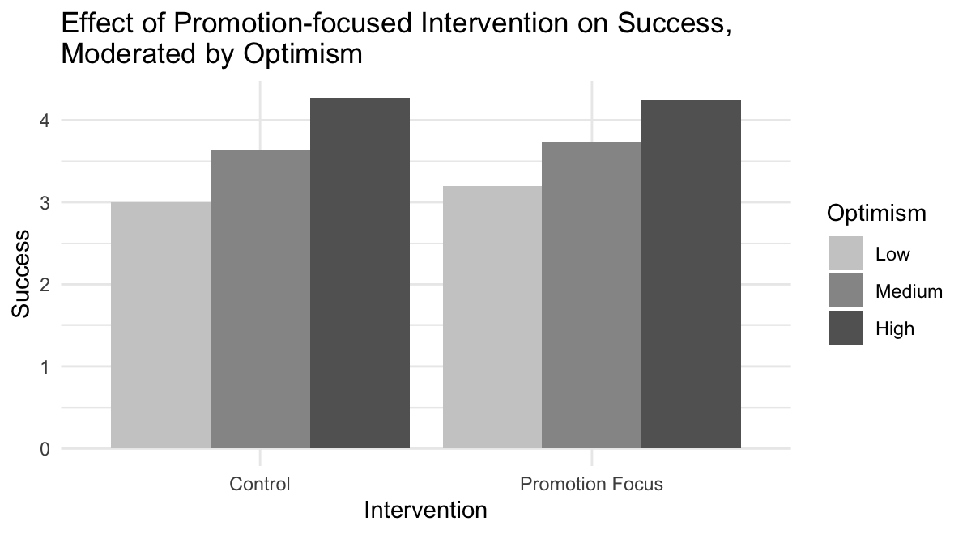

A moderation analysis was run, with promotion-focused interventions as the factor (Figure 1). In this analysis, promotion-focus was defined as being part of the promotion-focus group such that the promotion-focus group was contrasted with the control group. A significant main effect was found between intervention (ß = 0.36, p = .04) and career success, suggesting that participants in the promotion-focused group had increased feelings of career success over participants in the control group. The main effect between optimism and career success was significant (ß = 0.50, p < .001), suggesting that increased optimism is associated with increased feelings of career success. The interaction between promotion-focused intervention and optimism was non-significant (ß = -0.08, p = .12). Post hoc tests revealed that being in the promotion-focus group is associated with increased success levels for individuals with low (ß = 0.20, p = 0.01) and mid optimism (ß = 0.09, p = 0.007) and no significant differences for individuals with high optimism (ß = -0.01, p = 0.86).

Further analysis was conducted by including all intervention groups. Instead of an intervention group, we used the presence of promotion-focused intervention as a factor with two levels - present (for participants in the Promotion-Focus and Combined groups) and absent (for participants in the Active Control or Prevention-Focus group). This analysis also showed a significant positive main effect of both the presence of promotion-focused Intervention (ß = 0.37, p = .004) and optimism (ß = 0.57, p < .001). The interaction between the presence of promotion-focused intervention and optimism was significant (ß = -0.09, p = .03), yielding a different result from the first comparison which compared the intervention and control groups. Post hoc tests revealed that the presence of promotion-focused intervention is associated with increased success levels for individuals with low (ß = 0.20, p = 0 < .001) and mid optimism (ß = 0.09, p = 0.003) and no significant differences for individuals with high optimism (ß = -0.01, p = 0.75).

The similarity in results of both analyses suggests being in the promotion-focus intervention group was correlated with higher success levels for participants with low to mid optimism and no correlations with success levels among individuals with high optimism scores. While post hoc tests revealed similar trends in the effect of the promotion-focus intervention on low, mid and high optimism, the interaction effect is non-significant when only the promotion-focus and control groups are included, but significant when all groups are included, despite the interaction effects being similar in magnitudes (ß = -0.08 vs ß = -0.09). The difference in significance in the analyses is likely due to sample size as the latter analysis had a sample size close to double that of the former analysis due to the inclusion of the full sample size in the latter analysis. These results highlight the importance of statistical power in detecting true relationships with smaller effect sizes. Additionally, when continuous variables such as optimism are used as moderators, post hoc tests are crucial to understanding the effect of the factor, in this case, the intervention at different levels of the moderator.

Figure 2  
*Effect of endorsement of promotion-focus strategies on success, moderated by optimism*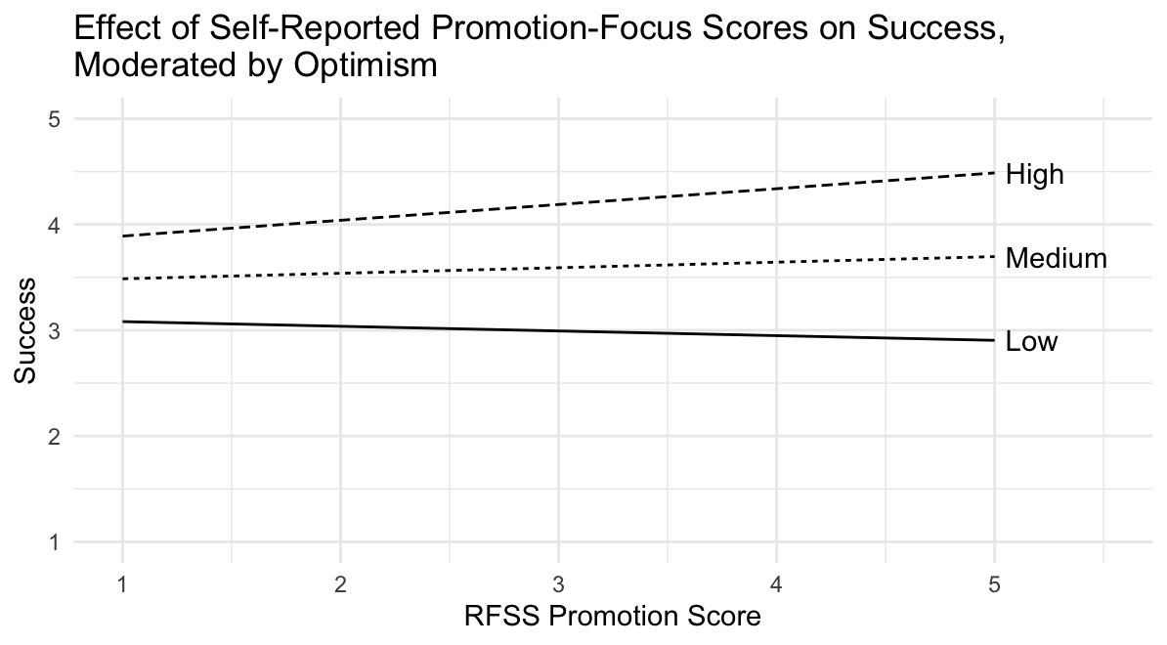

Promotion regulatory focus can also be operationalised in terms of endorsement of promotion-focus strategies, measured using the RFSS scale. Moderation analysis was run with the endorsement of promotion-focus strategies as a factor (Figure 2). Promotion endorsement had no significant main effect on success (ß = -0.18, p = .06) while optimism had a significant positive main effect on success (ß = 0.24, p = .04). The interaction between endorsement and optimism was significant (ß = 0.08, p = .01). This result suggests that increased endorsement of promotion-focused strategies are only associated with success for individuals with high optimism.

The results above have the following implications. For individuals with low to medium optimism, promotion-focused interventions are associated with higher success. For individuals with low optimism, greater endorsement of promotion-focused strategies is associated with higher success levels for individuals with high optimism.

### Future Predictions

The following moderation analysis examines the moderation of optimism on the relationship between promotion focus and future success.

Figure 3  
*Effect of promotion-focused intervention on future success, moderated by optimism*  
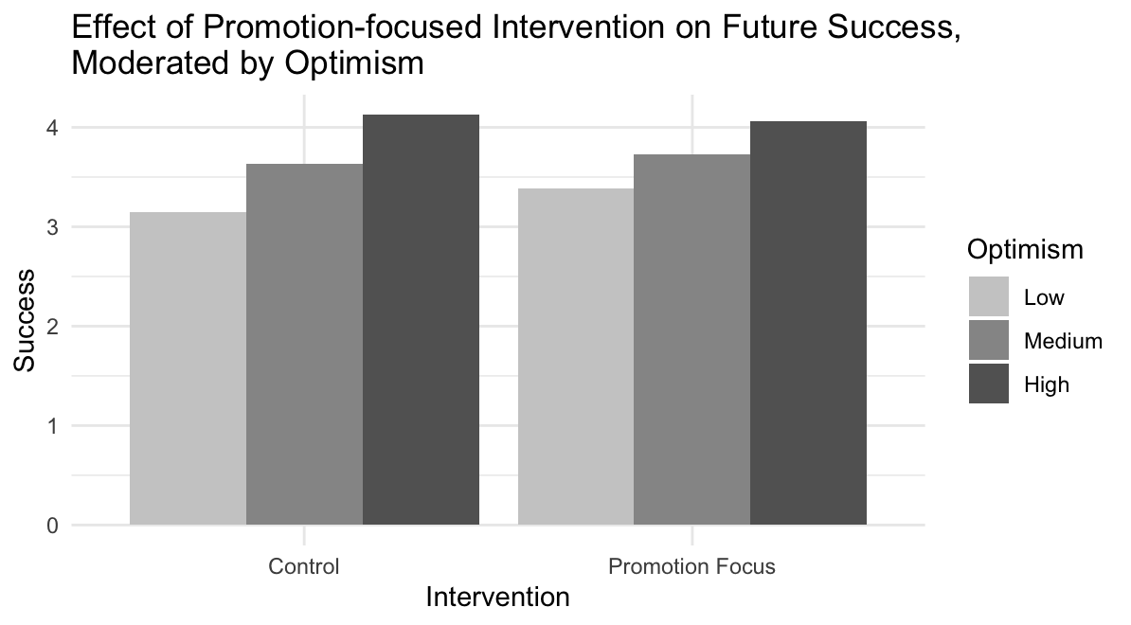

Comparing the promotion-focus group to the control group (Figure 3), the promotion-focus group had higher future success levels (ß = 0.47, p = .02). Increased optimism also predicts increased future success (ß = 0.39, p < .001). The interaction between promotion-focused intervention and optimism was non-significant (ß = -0.12, p = .05). However, post hoc tests suggest that the promotion-focus group is associated with increased future success levels for individuals with low (ß = 0.24, p = 0.005) and mid optimism (ß = 0.09, p = 0.02) and no significant difference in future success levels for individuals with high optimism (ß = -0.06, p = 0.48).

Analysis using all intervention groups and with the presence of promotion-focused intervention results yielded significant positive main effects of the presence of promotion-focused intervention (ß = 0.41, p = .005) and optimism (ß = 0.44, p < .01) on future success. The interaction between the presence of promotion-focused intervention and optimism is significant (ß = -0.10, p = 0.03). Similar to the case in concurrent correlations, it should be noted that the difference between the significance of the interaction effect of both analyses is likely due to increased statistical power in the second analysis due to increased sample size which allowed minute effects (ß = -0.12 in the former analysis and ß = -0.10 in the latter analysis) to be detected. Looking at post hoc tests can be more informative as post hoc tests point to a similar trend to the prior analysis, that the promotion-focused intervention is associated with higher success levels among individuals with low (ß = 0.22, p = 0.001) and medium optimism (ß = 0.10, p = 0.001) while and no significance difference in future success levels for individuals with high optimism (ß = -0.03, p = 0.64).

When endorsement of promotion-focus strategies is used with optimism as the moderator to predict future success, no significant main effects (ß = -0.01, p = .91 for endorsement of promotion, ß = 0.29, p = .07 for optimism) nor interaction effects (ß = 0.02, p = .57) were found.

The results reveal that promotion-focused interventions prove more effective for individuals with low to medium levels of optimism but show no significant influence on those with high optimism. These results suggest that the increase in the adoption of promotion-focused strategies increases future success. Among low and medium-optimism individuals, less promotion-focused strategies are used before the interventions, thereby allowing the promotion-focused intervention to significantly increase the use of promotion-focused strategies which increases future success. However, among high-optimism individuals who already use promotion strategies, the promotion-focused intervention was unable to further increase the adoption of promotion-related strategies, leading to no significant differences in future success.

## Moderation Effect of Stress on Prevention Regulatory Focus on Career Success

The second set of moderation analyses was conducted with prevention focus as a factor, stress as the moderator and career success as the dependent variable.

### Concurrent Correlations

Figure 4

*Effect of prevention-focused intervention on success, moderated by stress*

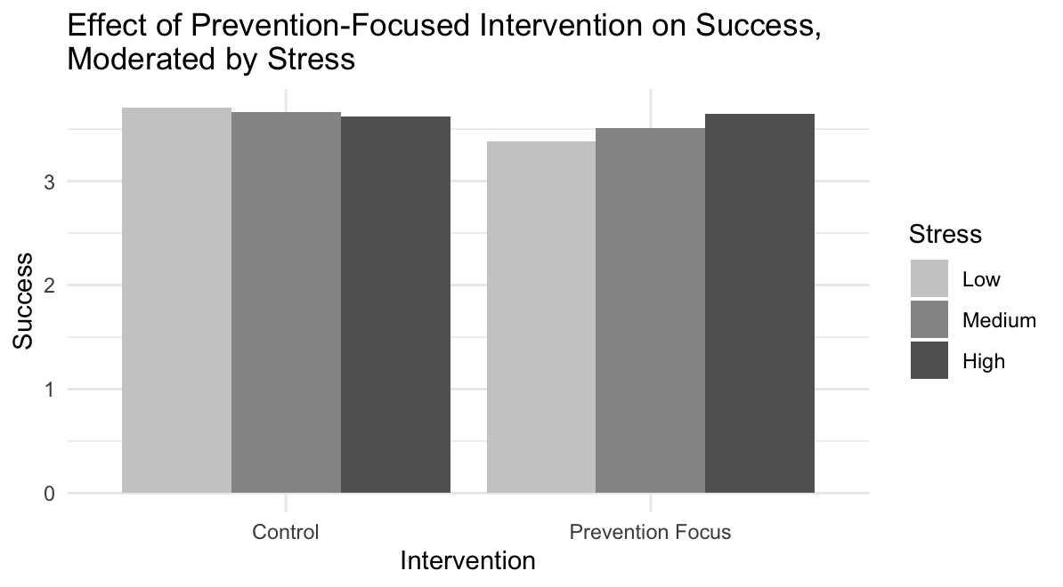

A moderation analysis was run, with intervention as the factor (Figure 4). In this analysis, intervention contrasted the difference between the prevention focus group and the control group. There was a significant main effect found between intervention (ß = -0.56, p = .02) and career success suggesting that being in the prevention-focus group was associated with decreased career success for participants with low stress. The main effect of stress on career success was non-significant (ß = -0.03, p = .54). The interaction between intervention and stress was significant (ß = 0.13, p = .05). Post hoc tests revealed that being in the prevention focus group is associated with decreased success levels for individuals with low stress (ß = -0.28, p = 0.01) and no significant differences for individuals with medium stress (ß = -0.08, p = 0.10) and high stress (ß = 0.12, p = 0.29).

Further analysis was performed using the presence of prevention-focused intervention as a factor with two levels to include results from participants in all groups in our analysis. The two levels were present (for participants in the Prevention-Focus and Combined groups) and absent (for participants in the Active Control or Promotion-Focus group). This analysis yielded similar results as the former analysis with intervention as the factor. There was a significant negative of the presence of prevention-focused intervention (ß = -0.44, p = .009), no significant effect of stress (ß = -0.06, p = .09) and significant interaction between the presence of prevention-focused intervention and stress (ß = 0.11, p = .02). Post hoc tests revealed that the prevention-focused intervention is associated with decreased success levels for individuals with low stress (ß = -0.21, p = 0.005) and no significant differences for individuals with medium stress (ß = -0.06, p = 0.08) and high stress (ß = 0.10, p = 0.20).

Figure 5  
*Effect of endorsement of prevention-focus strategies on success, moderated by stress*  
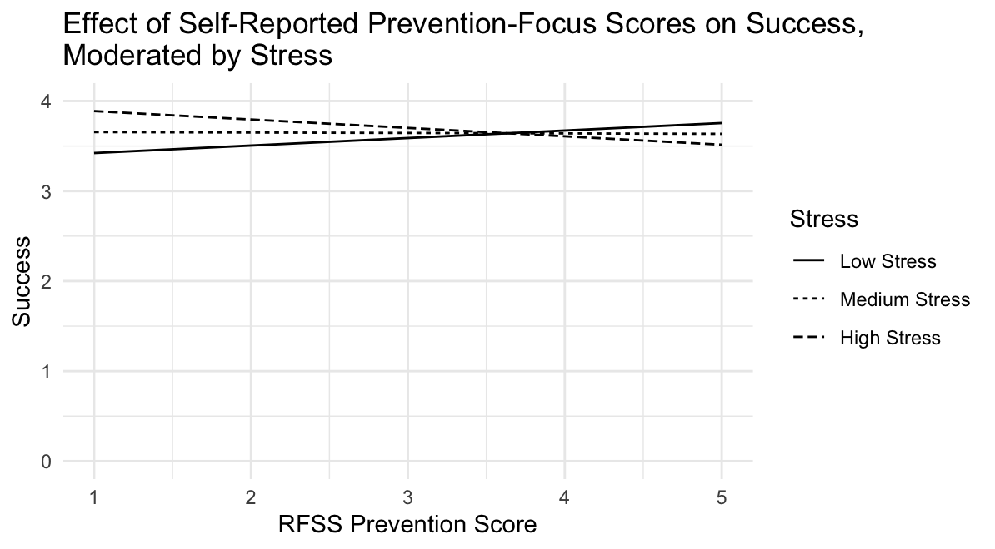

A separate moderation analysis was conducted with the endorsement of prevention-focused strategies as the factor. Endorsement of prevention had no significant main effect on success (ß = -0.21, p = .07) while stress had a significant positive effect on success (ß = 0.21, p = .05). The interaction between endorsement of prevention and stress was non-significant (ß = -0.06, p = .05). This result suggests that endorsement of prevention is not associated with success for individuals after their stress levels are considered.

The results indicate that prevention-focused interventions are associated with low success levels for individuals with low stress and no significant differences in success levels for individuals with medium and high stress.

### Future Predictions

Further analysis was done to examine the moderation of stress on regulatory focus in predicting future success.

Figure 6  
*Effect of prevention-focused intervention on future success, moderated by stress*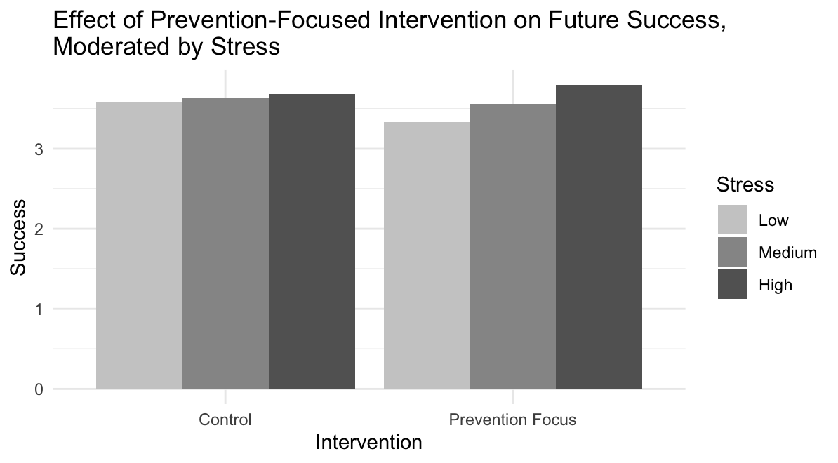

Comparing the prevention-focus group to the control group (Figure 6), the prevention-focus group had significantly lower future success levels (ß = -0.51, p = .03). Stress had no significant impact on future success (ß = 0.03, p = .48). The interaction between prevention-focused intervention and stress was non-significant (ß = 0.12, p = .06). Post hoc tests showed that for individuals with low stress, being in the prevention-focused group was associated with significantly lower future success (ß = -0.27, p = .02). For individuals with medium (ß = -0.07, p = .11) or high stress (ß = 0.11, p = .31), being in the prevention-focused group was not associated with changes in future success.

Figure 7  
*Effect of the presence of prevention-focused intervention on future success, moderated by stress*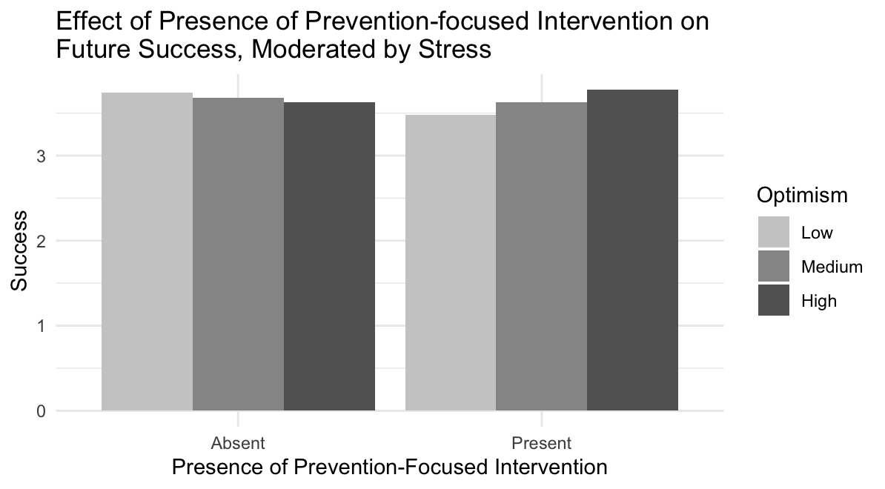

Analysis using all intervention groups in its sample and the presence of prevention-focused intervention as the factor results yielded a significant negative effect of the presence of prevention-focused intervention (ß = -0.55, p = .001) and non-significant effect of stress (ß = -0.04, p = 0.22) on future success. The interaction between the presence of prevention-focused intervention and stress is significant (ß = 0.14, p = 0.002). Post hoc tests showed pairwise comparisons at different stress levels revealed that the intervention decreased the future success of low-stress individuals (ß = -0.26, p = 0.005), did not impact the future success of medium-stress individuals (ß = -0.05, p = 0.10) and increased future success of high-stress individuals (ß = 0.15, p = 0.04). The use of the full sample size increased power which allowed the positive effect of the prevention-focused intervention on high-stress individuals to be detected.

When endorsement of prevention strategies scores is used as the factor, with stress as the moderator to predict future success, both main effects were non-significant (ß = 0.17, p = .19 for endorsement of prevention, ß = 0.20, p = .10 for stress). The interaction was non-significant (ß = -0.05, p = .16).

These results suggest that prevention-focused interventions affect individuals of different stress levels differently. Among those experiencing high or medium stress, these interventions seem neutral or potentially beneficial in influencing their future success levels. However, for individuals with low stress, these interventions are associated with reduced success levels. This interaction implies a negative impact on individuals with lower stress. This occurrence could be attributed to the limited stress-coping capacity of individuals with lower stress levels. For low-stress individuals, prevention-focused strategies might inadvertently trigger unnecessary stress, hindering their perception of career success. These results highlight the need for tailored interventions considering individual stress thresholds. Specifically, implementing prevention-focused interventions should be contingent upon individuals demonstrating a certain capacity to cope with stress.

# Conclusion

This study points to the importance of moderators like optimism and stress in the effectiveness of regulatory focus interventions. Regulatory focus interventions aim to change the strategy adopted by individuals in working towards their goals. The decision on whether to employ a promotion or prevention intervention should take into account individual capacity to adopt the strategy and traits of individuals that can influence the effectiveness of the strategy.

For promotion-focused interventions, this study suggests that their effectiveness is tied to their ability to increase the use of promotion strategies from the individual’s baseline. This baseline can be measured using proxies such as optimism. Promotion-focused intervention is only effective when the baseline usage of promotion strategies is sufficiently low to be further increased.

This study also suggests that prevention-focused interventions should be applied with caution. Prevention-focused interventions should only be applied to individuals assessed to have sufficient capacity to cope with stress induced by such strategies. Alternatively, interventions which increase stress-coping capacity can be applied alongside prevention-focused interventions to maximise the effectiveness of prevention-focused interventions in motivating individuals to work towards their goals.

The results of this study are part of the exploratory data analysis based on promotion-focused and prevention-focused interventions conducted. This study proposes pathways in which promotion-focused and prevention-focused interventions affect future success and highlights the importance of the consideration of moderators in this pathway. Further research can be done to understand whether the assignment of regulatory focus interventions in consideration of an individual’s baseline use of promotion-focus strategies and stress-coping capacity can improve the effectiveness of these interventions.

# 

# References

Higgins, E. T. (1998). Promotion and Prevention: Regulatory Focus as A Motivational Principle. In M. P. Zanna (Ed.), *Advances in Experimental Social Psychology* (Vol. 30, pp. 1–46). Academic Press.<https://doi.org/10.1016/S0065-2601(08)60381-0>

Higgins, E. T., Friedman, R. S., Harlow, R. E., Idson, L. C., Ayduk, O. N., & Taylor, A. (2001). Achievement orientations from subjective histories of success: Promotion pride versus prevention pride. *European Journal of Social Psychology*, *31*(1), 3–23.<https://doi.org/10.1002/ejsp.27>

Karasek, R., Brisson, C., Kawakami, N., Houtman, I., Bongers, P., & Amick, B. (1998). The Job Content Questionnaire (JCQ): An instrument for internationally comparative assessments of psychosocial job characteristics. *Journal of Occupational Health Psychology*, *3*(4), 322–355.<https://doi.org/10.1037/1076-8998.3.4.322>

Ouschan, L., Boldero, J. M., Kashima, Y., Wakimoto, R., & Kashima, E. S. (2007). Regulatory Focus Strategies Scale: A measure of individual differences in the endorsement of regulatory strategies. *Asian Journal of Social Psychology*, *10*(4), 243–257.<https://doi.org/10.1111/j.1467-839X.2007.00233.x>

Rottinghaus, P. J., Day, S. X., & Borgen, F. H. (2005). The Career Futures Inventory: A Measure of Career-Related Adaptability and Optimism. *Journal of Career Assessment*, *13*(1), 3–24.<https://doi.org/10.1177/1069072704270271>

Shockley, K. M., Ureksoy, H., Rodopman, O. B., Poteat, L. F., & Dullaghan, T. R. (2016). Development of a new scale to measure subjective career success: A mixed-methods study. *Journal of Organizational Behavior*, *37*(1), 128–153.<https://doi.org/10.1002/job.2046>

Stanton, J. M., Balzer, W. K., Smith, P. C., Parra, L. F., & Ironson, G. (2001). A General Measure of Work Stress: The Stress in General Scale. *Educational and Psychological Measurement*, *61*(5), 866–888.<https://doi.org/10.1177/00131640121971455>

# 

# Appendix A: Regulatory Focus Strategies Scale

(Ouschan et al, 2007)

Promotion

If you keep worrying about mistakes, you will never achieve anything.

To achieve something, you need to be optimistic.

You have to take risks if you want to avoid failing.

To avoid failure, you have to be enthusiastic.

Taking risks is essential for success.

If you want to avoid failing, the worst thing you can do is to think about making mistakes.

To achieve something, one must try all possible ways of achieving it.

The worst thing you can do when trying to achieve a goal is to worry about mistakes.

Prevention

Being cautious is the best way to avoid failure.

To avoid failure, one has to be careful.

To achieve something, it is most important to know all the potential obstacles.

To achieve something, one must be cautious.

Being cautious is the best policy for success.

To avoid failure, it is important to keep in mind all the potential obstacles that might get in your way.

# 

# Appendix B: Successful Career Success Inventory Scale

# 

(Shockley et al, 2016)

The stem for each item is “Considering my career as a whole...”

**Recognition**

...my supervisors have told me I do a good job.

...the organizations I worked for have recognized me as a good performer.

...I have been recognized for my contributions.

**Quality Work**

...I am proud of the quality of the work I have produced.

...I have met the highest standards of quality in my work.

...I have been known for the high quality of my work.

**Meaningful Work**

...I think my work has been meaningful.

...I believe my work has made a difference.

...the work I have done has contributed to society.

**Influence**

...decisions that I have made have impacted my organization.

...the organizations I have worked for have considered my opinion regarding important issues.

...others have taken my advice into account when making important decisions.

**Authenticity**

...I have been able to pursue work that meets my personal needs and preferences.

...I have felt as though I am in charge of my own career.

...I have chosen my own career path

**Personal Life**

...I have been able to spend the amount of time I want with my friends and family.

...I have been able to have a satisfying life outside of work.

...I have been able to be a good employee while maintaining quality non-work relationships.

**Growth and Development**

...I have expanded my skill sets to perform better.

...I have stayed current with changes in my field.

...I have continuously improved by developing my skill set.

**Satisfaction**

...my career is personally satisfying.

...I am enthusiastic about my career.

...I have found my career quite interesting.

# Appendix C: Moderators

* R represents items negatively recoded

(Rottinghaus et al, 2005)

Optimism

I get excited when I think about my career.

Thinking about my career inspires me.

Thinking about my career frustrates me. (R)

It is difficult for me to set career goals. (R)

It is difficult to relate my abilities to a specific career plan. (R)

I understand my work-related interests.

I am eager to pursue my career dreams.

I am unsure of my future career success. (R)

It is hard to discover the right career. (R)

Planning my career is a natural activity.

I will definitely make the right decisions in my career.

(Stanton et al, 2001)

(Karasek et al, 1998)

Stress

Demanding

Work very fast

Work very hard

Pressured

Hectic

Calm (R)

Relaxed (R)

Stressful

Pushed

# 

# Appendix D: Plots for all analyses

The graphs for all analyses run are appended below.

## Promotion-Focus X Optimism

### Coexisting Correlation



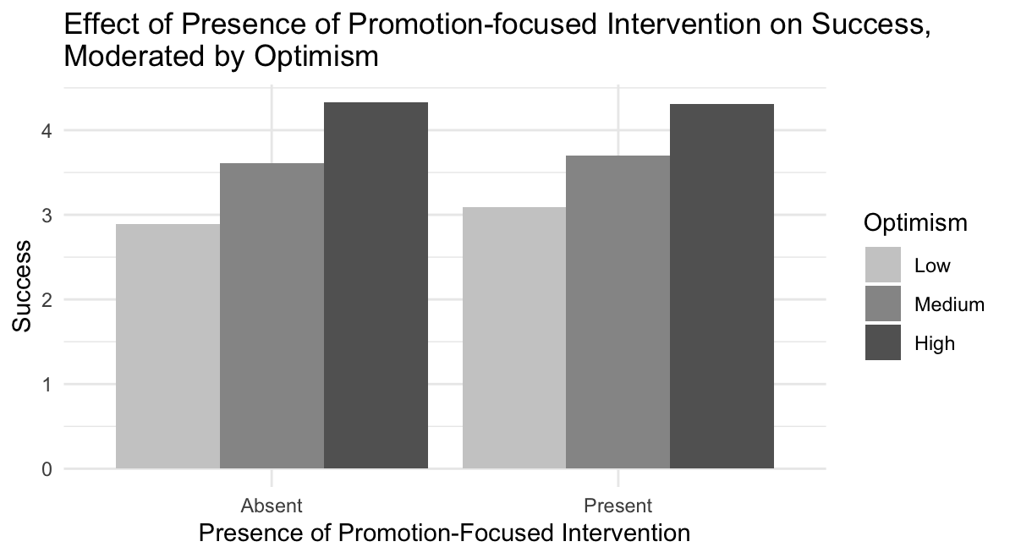



### Future Predictions



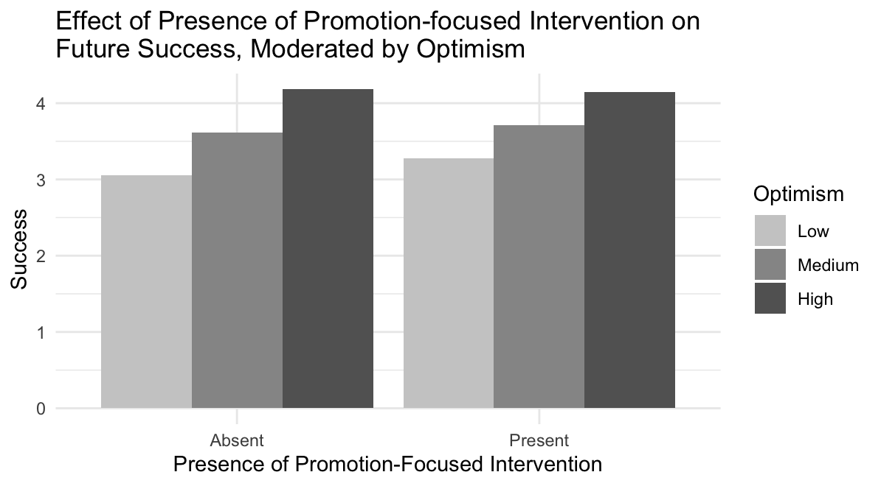

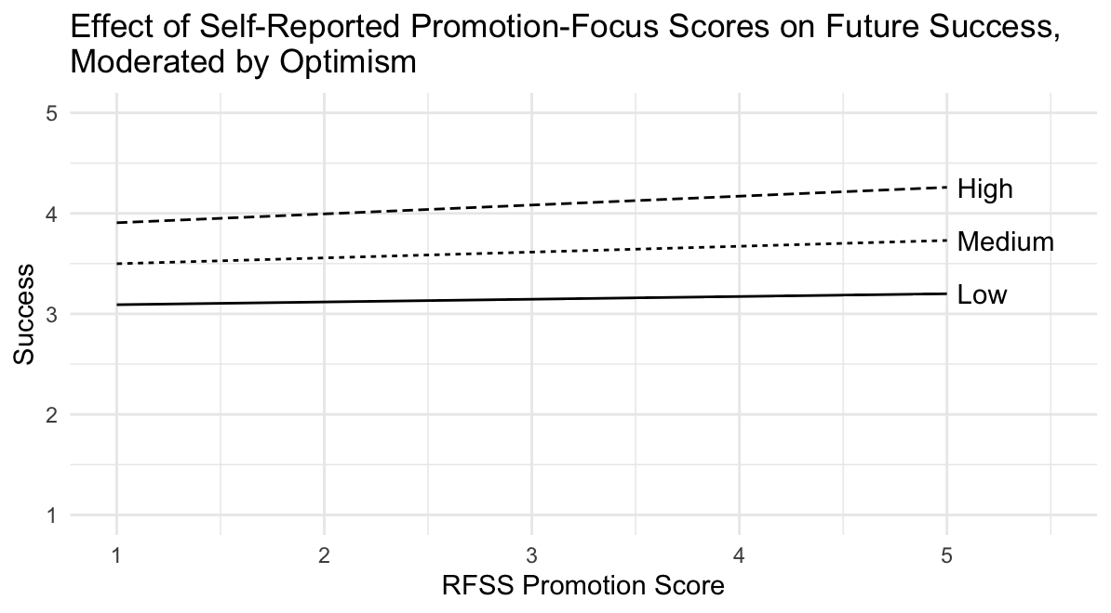

## 

## Prevention-Focus X Stress

### Coexisting Correlations



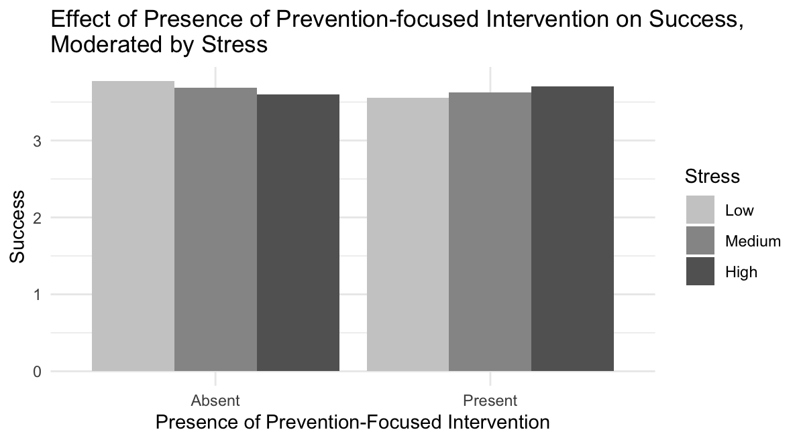



### 

### Future Predictions





